DTSC 671: AI Solutions in the Cloud

Object Recognition with Amazon Rekognition

Goal
Your organization wants a cloud solution to classify objects in pictures that users upload to their website. Once users upload pictures, the organization wants to use computer vision to detect various appropriate (and inappropriate) images in the file.

In this assignment, you will upload a picture to an S3 bucket, which will trigger a Lambda function. The Lambda function will call the Amazon Rekognition API to perform object detection on the picture, then store a JSON file with a list of the images (with confidence level) in a separate S3 bucket.

You will submit the template with the requested screenshots on Brightspace. Please note you only have one submission attempt.

Architectural Overview




S3 upload triggers Lambda function which uses Rekognition to convert analyze JPG and store object information in JSON
Lambda saves JSON file in different S3 bucket
Upload JPG file to S3 bucket
User uploads picture, which is sent to S3 bucket

IAM role gives Lambda the permissions to retrieve and store files in S3 and call Rekognition API


Pricing Estimate
IAM role enables Lambda to create CloudWatch log to track activity
The following estimate shows the costs you may incur on your AWS personal account.

AWS Pricing Estimate
Service | Calculation | Cost
S3 Standard Storage | You will store a JPG file in one bucket and have a JSON file as output in another bucket.  - JPG file size estimate: 3 MB  - JSON file size estimate: 300 KB  The total size is 3.3 MB = 0.0033 GB  S3 Standard pricing is roughly $0.023 per GB per month (varies slightly by region).  0.0033 GB × $0.023/GB = $0.0000759 per month | $0.01
Lambda | Lambda assumption:  - Memory allocated: 128 MB  - Execution time: 2460 ms (billed + initial)  - Requests: 1  - GB-seconds: (128 MB ÷ 1024) × 2.460 sec = 0.3075 GB-sec  Lambda pricing:  - Free tier: 1M requests & 400,000 GB-seconds/month  Cost Calculation (if beyond free tier)  - Cost: 0.3075 GB-second × $0.00001667 = $0.000005126 | Free tier
Rekognition use in Lambda function | The free tier period lasts 12 months from the date of account creation. Image analysis: During the free tier period you can analyze 1,000 images per month for free each, in Group 1 and Group 2 APIs.  This assignment uses a Group 2 API: DetectLabels.  After free tier pricing:  - For the first 1 million images under Group 2, $0.001 per image  - 1 image × ($0.001) = $0.001  If, for instance, you’re not under the free tier and you use the API 100 times while troubleshooting your lab, then 100 × ($0.001) = $0.10 | Free tier

Directions
Make sure that all your services are in the same region (e.g., us-east-1)
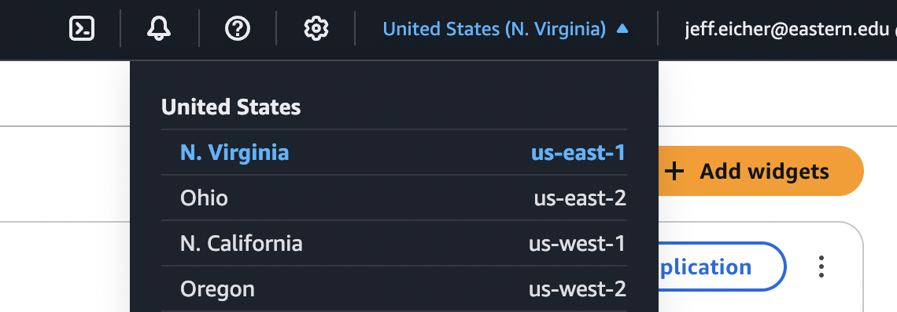

STEP 1: Find or create an image
- Find an image to upload. There are many free images available at various websites.
- It’s helpful if the image has multiple objects in it, not just a simple image of a flower and nothing else.
- I recommend noting the size of the image, and keeping it in the low MB range. (The pricing estimate above gives 3 MB as an estimate.)
- If not already, convert the image to a JPG (being careful of the size).

STEP 2: Create two S3 buckets
- Name one bucket dtsc-671-rekognition-input-<term>-<year>-<name>
  - For example, dtsc-671-rekognition-input-fa1-2025-jeffeicher
  - Include tags for cost tracking; such as key: dtsc-671 value: rekognition
- Name one bucket dtsc-671-rekognition-output-<term>-<year>-<name>
  - For example, dtsc-671-rekognition-output-fa1-2025-jeffeicher
  - Include tags for cost tracking; such as key: dtsc-671 value: rekognition
- Note: We are not loading anything in the S3 buckets at this point in the assignment

How do I make an S3 bucket?
Tutorial: How do I make an S3 bucket?

STEP 3: Create, Set Up, Configure, Code Lambda function
- Create a Lambda function with the name: object-recognition-<name>
  - For example, object-recognition-jeffeicher
  - Use Runtime: Python 3.14
  - Create a new role with basic Lambda permissions
  - Include tags with the key-value pair as dtsc-671 and rekognition, respectively
- Set up the Lambda function.
  - Make the trigger the input bucket you created above.
    - Include a file extension of .jpg as the optional suffix.
  - Make the destination the output bucket you created above.
- Configure the Lambda function.
  - Change the “Timeout” from 3 seconds to 1 minute.
  - Set IAM role permissions: The role must have basic lambda permissions (which includes CloudWatch logging), S3 access to both buckets, and calling the Rekognition API. Follow the “principle of least privilege”.
- Write code for the Lambda function.
  - We want Lambda to take the file in S3, use the Rekognition API and make a JSON out of it.
    - We encourage you to use an LLM (like ChatGPT, Gemini, etc.) to help you write and debug the code for your Lambda function
    - Include print statements through your code to help troubleshoot.
  - We want the label and the confidence output from Rekognition to be shown in the JSON. (See step below for screenshot example output).
  - Make sure that the title of the JSON matches the title of the original JPG file (other than the extension changed from .jpg to .json)
  - In this assignment, you'll use the Amazon Rekognition API method detect_labels in your code. Here is the relevant documentation.
  - Anytime you make edits to your code, be sure to hit “Deploy”; otherwise, your updated code will not run.
  - Wait until the green banner shows the function has been deployed before moving on.

STEP 4 (Test): Upload your JPG image to the input bucket
- Once all the previous steps have been completed, upload the JPG file of the image you selected above in the input S3 bucket
- Even if you’re not sure your code will work, you can upload the JPEG file and see what happens! As long as the JPG file isn’t large (more than a few MB) the costs will be very minimal (i.e., <$0.001).

STEP 5: Was the Lambda function successful?
There are multiple ways to check if your Lambda function is correct.
- Check your S3 output bucket. Is there a JSON file there? If so, does it look something like the following? (The labels will differ from image-to-image.)
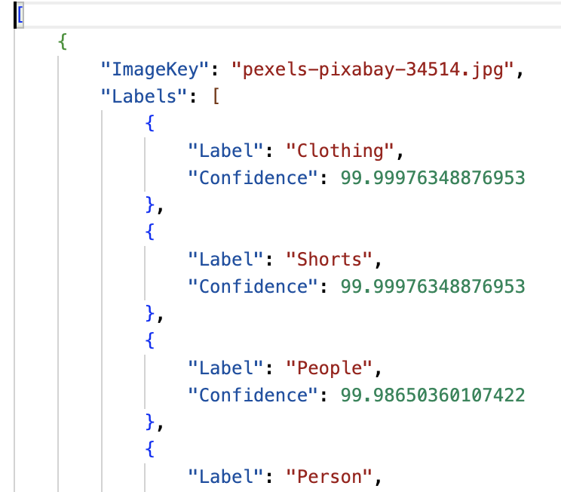

- You can go to the “Monitor” tab in your Lambda function, and select “View CloudWatch logs”.

STEP 6: Troubleshoot

- How do I use CloudWatch logs to troubleshoot my code and architecture?

- Use an LLM to troubleshoot
  - When writing prompts to develop your code, ask the LLM to include error handling to help you diagnose issues with your code or architecture.
  - Give the LLM information such as your Runtime (i.e. Python 3.14)
  - The LLM will likely give you a list of error possibilities. Work carefully through each one. If there’s still an error, let the LLM know what you did to fix any issues.
  - After you have tried troubleshooting with an LLM, if you email the GAs or professor, you must include screenshots of your architecture and error messages.

- Reupload (or overwrite) your JPG to the S3 input bucket. This action will trigger the lambda function to run again. If a JSON with the necessary output is not stored in the S3 output bucket, keep troubleshooting.

- What information does the professor or GA expect in order to assist you?
  - Helping you is much different than classes with CodeGrade—we can’t simply jump into your AWS account and troubleshoot!
  - We expect one or both of the following:
    - Screenshots of your architecture, following each step above, so we can find where the issue may be
    - A video showing your architecture, including the error messages in CloudWatch.
  - An email that says “my lambda function is not working” is not sufficient and is not helpful
  - Do not post your lambda function code on the discussion boards. All other information and questions can appear there.

STEP 7: Brightspace submission
- Download the assignment template with requested screenshots as a PDF document (File > Download > PDF Document). Submit your template PDF to the Brightspace assignment.

This is course material that was distributed to students enrolled in DTSC 671 at Eastern University. The materials were made exclusively available to students solely for the purpose of completing the course and are not intended for further distribution or retention beyond the course period. The materials were created by program faculty specifically for use in courses at Eastern University.

